**PATIENT APPOINTMENT SYSTEM**

**A MAJOR PROJECT REPORT**

SUBMITTED IN PARTIAL FULFILLMENT OF THE REQUIREMENTS FOR THE AWARD OF THE DEGREE OF

**BACHELOR OF TECHNOLOGY**

(Computer Science & Engineering)

**SUBMITTED TO**

**PUNJAB TECHNICAL UNIVERSITY, JALANDHAR**

**SUBMITTED BY**

Name of Student University Roll No.

Nidhi Jain 100640309343

02-01-2014 to 15-05-2014



**RIMT- INSTITUTE OF ENGINEERING & TECHNOLOGY,**

**MANDI GOBINDGARH**

**PUNJAB**

**PATIENT APPOINTMENT SYSTEM**

**A MAJOR PROJECT REPORT**

SUBMITTED IN PARTIAL FULFILLMENT OF THE REQUIREMENTS FOR THE AWARD OF THE DEGREE OF

**BACHELOR OF TECHNOLOGY**

(Computer Science & Engineering)

**SUBMITTED TO**

**PUNJAB TECHNICAL UNIVERSITY, JALANDHAR**

**SUBMITTED BY**

Name of Student University Roll No.

Nidhi Jain 100640309343

02-01-2014 to 15-05-2014



**RIMT- INSTITUTE OF ENGINEERING & TECHNOLOGY,**

**MANDI GOBINDGARH**

**PUNJAB**

**CERTIFICATE**

I hereby certify that I have completed the Six months Training in partial fulfillment of the requirements for the award of **Bachelor of Technology in Computer Science Engineering.** I did my training at Oops Info Solutions Pvt. Ltd., SCO 110-111, Top Floor, Sector 34 A, Chandigarh from 02-01-14 to 15-05-14.

The matter presented in this Report has not been submitted by me for the award of any other degree elsewhere.

**Signature of Student**

Nidhi Jain (100640309343)

#### 

#### Signatures

#### Examined by:

#### 1. 2. 3. 4.

**HOD**

**Computer Science Engineering Department**

# CERTIFICATE

This is to certify that Ms. Nidhi Jain, University Roll No. 100640309343 completed the Training in our Organization during the period 01-01-14 to 15-05-14. Their overall performance during the period was Excellent.

**Signature & Seal of Training Manager**

**TABLE OF CONTENTS**

|  |  |
| --- | --- |
| **Title** | **Page No.** |
| Acknowledgement.................................................................................................. | i |
| About Institute........................................................................................................ | ii |
| List Of Tables......................................................................................................... | iii |
| List Of Figures....................................................................................................... | iv |
| Abbreviations......................................................................................................... | v |
| **Chapter 1: INTRODUCTION** |  |
| 1.1 Disadvantages of Existing System………………………………. | 1 |
| 1.2 Computer Aided Medical Diagnosis System (CAMD)…………. | 2 |
| 1.3 Features of Project.......................................................................... | 2 |
| 1.4 Technologies Used......................................................................... | 4 |
| **Chapter 2: PROJECT WORK** |  |
| 2.1 Modules.......................................................................................... | 5 |
| 2.1.1 Admin Module………………………………………………… | 5 |
| 2.1.2 Doctor Module………………………………………………… | 6 |
| 2.1.3 Patient Module............................................................................ | 7 |
| **Chapter 3: HARDWARE REQUIREMENTS** | 8 |
| **Chapter 4: SOFTWARE REQUIREMENTS** |  |
| 4.1 System Implementation................................................................... | 9 |
| 4.2 Overview of JAVA......................................................................... | 9 |
| 4.2.1 Characteristics Of Java................................................................. | 10 |
| 4.2.2 Java Platform................................................................................. | 11 |
| 4.2.3 Different Modules Of Java............................................................ | 11 |
| 4.3 Introduction to Mysql...................................................................... | 18 |
| **Chapter 5: DATA FLOW DIAGRAMS (DFD’S)** | 22 |
| **Chapter 6: SCREEN SHOTS** | 27 |
| **Chapter 7: RESULT & DISCUSSION** | 48 |
| **Chapter 8: FUTURE & SCOPE** | 49 |
| References........................................................................................... | 51 |

**ACKNOWLEDGEMENT**

We would like to place on record our deep sense of gratitude to Mr. Manjeet Singh Java expert at Oops Info Solutions Pvt. Ltd. Chandigarh for his generous guidance, help and useful suggestions.

We express my sincere gratitude to Mr. Umesh, HTML and CSS expert at Oops Info Solutions Pvt. Ltd., Chandigarh for his stimulating guidance, and continuous encouragement.

We are extremely thankful to Prof. Anuj Gupta, HOD, RIMT IET, Mandi Gobindgarh, for valuable suggestions and encouragement.

I am also thankful to Mr. ………………., Training and placement officer, RIMT-IET, Mandi Gobindgarh for providing the opportunity to get the knowledge.

**Signature of Student**

Nidhi Jain (100640309343)

**ABOUT INSTITUTE**

Oops Infosolutions was established in 2003. It's foundation and purpose is to provide and construct programs for existing companies and provide new and exciting updates to primitive bases technology.

Oops Infosolutions started in Mohali which is situated in Punjab, India and was the one of the first to be opened in the vicinity. Oops Infosolutions first started with the education in India, through their curriculum. They were able to negotiate a service that was accessible to all students and post Graduates (this continued with great success). They also provide study materials i.e. program languages C, C++, Visual C++, VB, VB.Net, ASP.Net, XML, Oracle 9i, Sql Server 2000, ASP, Java, and Advance Java, Multimedia (Flash MX, Director MX, Fireworks MX, and Dreamweaver MX). This institute has now expands its network to other countries such as England, USA. This has been met with much appreciation & support. Oops Infosolutions is now entering its 11th successful year. Through networking they are able to provide a service to all races of people.

**LIST OF TABLES**

|  |  |  |
| --- | --- | --- |
| **Figure** | **Title** | **Page** |
| 4.2.1 | Component-to-Model mapping for Swing................. | 13 |
| 4.2.2 | Scope and state maintenance in JSP.......................... | 14 |
| 4.3.1 | Operating system Vs file-size limits.......................... | 21 |

**LIST OF FIGURES**

|  |  |  |
| --- | --- | --- |
| **Figure** | **Title** | **Page** |
| 4.2.1 | Compilation Of Java Program........................................ | 10 |
| 4.2.2 | Java Platform.................................................................. | 11 |
| 4.2.3 | Basic JSP Request Model............................................... | 14 |
| 4.2.4 | Struts 2 Working............................................................. | 16 |

**ABBREVIATIONS**

|  |  |
| --- | --- |
|  |  |
| API | Application Programming Interface |
| JVM | Java Virtual Machine |
| AWT | Abstract Windowing Toolkit |
| MVC | Model View Controller |
| JSP | Java Server Pages |
| HTML | Hyper Text Markup Language |
| CSS | Cascading Style Sheet |
| SQL | Structured Query Language |
| DFD | Data Flow Diagram |

**1.** **INTRODUCTION**

This project aims to introduce a **Patient Scheduling Online Service** for health care institutions that would ease off the appointment-scheduling journey for users and pave the path of a better doctor-patient experience. The proposed system advances with online facilities that eliminate the chaos of traditional appointment services. This system offers online appointment booking, to view doctors list, to cancel and update appointments with an administrative portal to manage all the sections. It provides advanced functionality to streamline the process thus easy access to personal hospital services that help organizations to stay connected with their customers, clients and most importantly patients and can result in significant time and monetary savings In to order to develop a successfully running online Patient Scheduling, the system is required to interact with system database, scheduling module and the administrative module for example, to achieve the best implementation, the scheduling system would be able to interact with several medical health care staff such as physicians, nurses admin staff and patients.

## Problem Context

Online Patient Scheduling also commonly known as Online Appointment booking system an optimized phase of medial healthcare service to improve patient healthcare journey in hospitals and clinics. Motivated by the rising popularity of electronic appointment booking system, this project aims to develop an appointment-scheduling model that takes into account the patient preferences regarding when they would like to be seen. Currently, it is rational to establish the fact that, very few hospitals provide online scheduling doctor-patient session.

**1.1 Disadvantages of Existing System**

The disadvantages of current system are all those associated with manual working systems. It is time consuming to produce appointment sheets or reports as compared to any other computerized system. Humans are more probes to errors so always possibility of errors in managing records. It is very difficult and time consuming to manage the medicine stocks manually. Patients are not able to check their disease online. Chemists contact with doctors in case of any discrepancy related to any medicine.

* Patients have to run to doctors every time.
* No use of Web Services and Remoting.
* Risk of mismanagement and of data when the project is under development.
* Less Security.
* No proper coordination between different Applications and Users.
* Fewer Users - Friendly.
* Manual system need man power a lot.
* Communication between Doctor and Patient is not directly.
* It is less user-friendly.

**1.2 Appointment Booking System**

Involves everything that has to do with the management of medicines, doctors, patients, appointment details etc. This is basically used to build a web application program that a company uses to manage the records of the doctors, patients and medicines. Only the administration has the legal rights to work with the system. Patient can only log on to the system to see their current status and prescribe the medicines to patients. To manage all the information about the Details of the medicines

* To manage all the information about the medicines, according to the abbreviation to be used.
* To manage all the information about the medicines according to the Chapter, Topic.
* To manage all the information about the medicines, according to the Salt.
* To manage the stock of medicines.
* To check the disease by matching the symptoms by a patient.
* Administrator has the privilege that he can create, modify the database.
* It modifies the information when need arises of the new patients and doctors.
* To intimate user according to the threshold value set for Quantity.
  1. **Features of Project**

The use of computer in medical applications continues to be widely increased dramatically throughout the last three decades. Traditionally, with this field, information technology has been utilized to read, scan, store, process, retrieve and analyze medical information. They have already been used as being a tool inside Computer Aided Diagnosis and proper care of patients.

An expert method is a **patient appointment system** that control flow of patient appointments and generate display board for each day so a sequence of appointments can be handled and expert system deal with emergency levels which may be Emergent,Urgent,No-Urgent and the highest emergency level patient are attended first and display board is automatically refereshed to re-arrange the appointments. These examples from your through the problem domain can either have the correct class labels related to them, categorized as supervised learning, or sub–classes of examples can automatically be found from the inside the data.

* **User Friendly**: The system produced is user friendly, understandable and easy to use so that the users of the system can easily learn to use the system. For this the system is made menu-driven with well-documented programs.
* **Time Element (response and processing time)**: The response time of the system is very less and takes less time to execute queries and triggers.
* **Maximum Throughput**: The system gives maximum throughput with relevant output
* **Robustness**: The system will be able to handle undesirable situations and errors encountered at various levels e.g. if the user supplies invalid input for processing, the system gracefully halts, displaying a message to the user indicating the cause of the error and prompting him it enter the correct input.
* **Flexibility:** The system is flexible in nature so that likely changes and alterations can easily be made.
* **Information Security:** Records in the system must be safe, confidential and must be prevented from unauthorized access.
* **Moral and User Satisfaction**: System will be able to satisfy the user requirements; this is the main and conspicuous measure of the system performance. Also the system must raise the moral of the user. The higher the moral, greater the expected work performance level.

**The Inputs Required for this System are:**

* Login.
* Patient Maintenance
* Appointment maintenance.

**The Outputs Required for this System:**

* Patient Reports
* Appointment Report
* Symptom checker
* Logout

**1.4 Technologies Used**

FRONT END JAVA

BACKEND JDK1.8.0

JAVA: The Java Development Kit (JDK)

MySQL: MySQL is an open source relational database management system (RDBMS) that runs as a server providing multi-user access to a number of databases. MySQL is a relational database management system (RDBMS), and ships with no GUI tools to administer MySQL databases or manage data contained within the databases.

1. **PROJECT WORK**

Information technology has been like a boom in almost every kind of management system. The continuous improvement in the field of technology along with increasing complications in day-to-day life has resulted in the online information system. The availability of the software’s for almost every process or every system has taken the world in its top-gear and fastens the day-to-day life. So, we have tried our best to develop this software program.

In this Project I have made a Hospital website which performs tasks very efficiently. This project name is Appointment Booking System for Patient. In this System Patients can request appointments after they login. The request is forwarded to surgery staff (admin) which process the request and assign them priority. Patients can view the display board for the confirmation of their appointments and they can see the token no being assigned them according to their emergency level. They can also request for the appointment to the specialized doctors in this hospital and meet them for further tests.

**2.1 Modules**

The system after careful analysis has been identified to be presented with the following modules:

**The modules involved are:**

1. Admin Module 2. Patient Module

**2.1.1 Admin Module** - Admin Module means Administrator Module. In this module or panel, the Administrator has the privileges to Add, Delete & Modify the database. Administrator will have complete control of the system. Admin operates the whole system. He will be responsible for managing all the records of the system and generating various reports.

This Module is divided into different sub-modules.

1. Doctor Management
2. Patient Management
3. Appointment Management
4. **Doctor Management-** In Doctor Management, Admin can add, modify and delete the doctor details. He provides the privileges to confine the view upto a limit so that doctors cannot manipulate all data own their own.
5. **Patient Management-** In Patient Management, Admin can add, modify and delete the Patient details. He provides the privileges to confine the view upto a limit so that patients cannot manipulate all data own their own.
6. **Appointment Management-** In Appointment management, Admin can manage appointments requested by patients and allotted them token no.
   * 1. **Patient Module –** In this Module Patients can check their personal details, they can match the symptoms and conclude about the disease they have, they can also request for the appointment , They can also change their password if necessary.

This Module is divided into different sub-modules.

1. View Personal Details
2. Symptom Checker
3. Request Appointment
4. Change Password
5. **View Personal Details**- Here the Patient who have login, that very particular Patient can view his personal details, He can also modify his Particulars if he want to.
6. **Symptom Checker**- Here Patients can match their symptoms and can find what disease they are suffering from and what are the medicines required to treat that disease.
7. **Request Appointment**- Here Patients can request for the appointment for checkup to the specialized doctor in the area they are suffering disease.
8. **Change Password**- Here Patients can change their password if they wish to do so.
9. **HARDWARE REQUIREMENTS**

* Intel(R) Pentium(R) i3 Processor minimum or higher is recommended.
* 4 GB RAM minimum (8GB RAM is recommended)
* Disk space: We will require 500 GB maximum disk space for installing the full Show Organizers application and additional disk space for the resources that we develop. We will require additional disk space to meet the database requirements.
* Display resolution:

For Windows.800 x 600 display minimum (1024 x 768 )

For Linux.1024 x 768 display minimum.

**4. SOFTWARE REQUIREMENTS**

This section contains all the software requirements at a level of detail. These are as follows.

* Operating System : Windows 9X/XP, Windows Vistas, Windows 7.
* IDE : NetBeans 8.0.1
* Technology : Struts, JSP, Jquery, Servlets
* Web Technologies : Html, CSS
* Database : MySql 5.0, WampServer
* Web Server : apache tomcat 8.0.32
* Development kit : jdk-8

**4.1 System Implementation**

Implementation implies what configurations are required to implement the given software at the end user’s site.

* There must be JDK loaded on all the computers that will provide support to the computer on which the application is running. Then, install the installation on the system using its installer.
* There must be MySQL Server 5.0 installed on the system to provide the support of database.

After the system is implemented, a review of the system is conducted by the users and the analysts alike to determine how well the system is working, how it has been accepted and whether any adjustments are needed.

**4.2 Overview of JAVA**

Java is an object-oriented programming language with a built-in application programming interface (API) that can handle graphics and user interfaces and that can be used to create applications or applets. Because of its rich set of API's, similar to Macintosh and Windows, and its platform independence, Java can also be thought of as a platform in itself. Java also has standard libraries for doing mathematics.

In Java we distinguish between applications, which are programs that perform the same functions as those written in other programming languages, and applets, which are programs that can be embedded in a Web page and accessed over the Internet. Our initial focus will be on writing applications. When a program is compiled, a byte code is produced that can be read and executed by any platform that can run Java.

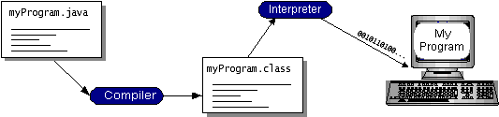

Fig.4.2.1 Compilation of java Program

**4.2.1 Characteristics Of Java:**

1.Platform Independent

2. Robust

3. Object Oriented

4. Multithreaded

5. High Performance

6. Dynamic

## Speciality Of Java: Java is a programming language for distributed applications. It doesn't just allow you to add new types of content to your pages like Netscape and Internet Explorer do. Rather it lets you add both the content and the code necessary to interact with that content .

Here are just a few of the many things Java can do for a web page:

* Inline sounds that play in real-time whenever a user loads a page
* Music that plays in the background on a page
* Cartoon style animations
* Real-time video
* Multiplayer interactive games

## 4.2.2 Java Platform:

A java platform is the hardware or software environment in which a program runs. The java platform has two components:

1. Java Virtual Machine (JVM)

2. Java Application Programming Interface (Java API)

**1.** **Java Virtual Machine (JVM)** : JVM is a standardized hypothetical computer, which is emulated inside your computer by a program.

**2. Java Application Programming Interface (Java API)** : The Java API is a large collection of ready-made software components that provide many useful capabilities, such as graphical user interface (GUI). The java API is grouped into libraries of related classes and interfaces these libraries are known as packages.

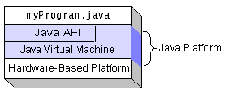

Fig.4.2.2 Java Platform

**4.2.3 Different Modules Of Java:**

1. AWT: The Java programming language class library provides a user interface toolkit called the Abstract Windowing Toolkit, or the AWT. The AWT is both powerful and flexible. Newcomers, however, often find that its power is veiled. The class and method descriptions found in the distributed documentation provide little guidance for the new programmer. Furthermore, the available examples often leave many important questions unanswered. Of course, newcomers should expect some difficulty. Effective graphical user interfaces are inherently challenging to design and implement, and the sometimes complicated interactions between classes in the AWT only make this task more complex. However, with proper guidance, the creation of a graphical user interface using the AWT is not only possible, but relatively straightforward.

2. APPLET: Applets are small Java programs that are embedded in Web pages. They can be transported over the Internet from one computer (web server) to another (client computers). They transform web into rich media and support the delivery of applications via the Internet. Although Java is a general-purpose programming language suitable for a large variety of tasks, the task most people use it for is applet programming. An applet is a Java program that executes on a World Wide Web page. When the prerelease versions of the Java Developers Kit were made available in 1995, the demonstration programs that drew international attention to the language were applets.

The current uses of applets include the following:

* Tickertape-style news and sports headline updates
* Animated graphics
* Video games
* Student tests
* Image maps that respond to mouse movement
* Advanced text displays
* Database reports

**3. SWING:** Most Swing developers know by now that Swing components have a separable model-and-view design. And many Swing users have run across articles saying that Swing is based on something called a "modified MVC (model-view-controller) architecture."

But accurate explanations of how Swing components are designed, and how their parts all fit together, have been hard to come by -- until now.

The silence ends with the publication of this article, a major white paper on Swing component design. It provides a comprehensive technical overview of Swing's modified MVC structure and demystifies many other facets of Swing component architecture as well. This document presents a technical overview of the Swing component architecture. In particular, it covers the following areas in detail:

* Design goals
* Roots in MVC
* Separable model architecture
* Pluggable look-and-feel architecture Design Goals

|  |  |  |
| --- | --- | --- |
| **Component** | **Model Interface** | **Model Type** |
| JButton | ButtonModel | GUI |
| JCheckBox | ButtonModel | GUI/data |
| JRadioButton | ButtonModel | GUI/data |
| JMenu | ButtonModel | GUI |
| JMenuItem | ButtonModel | GUI |
| JSlider | BoundedRangeModel | GUI/data |

**Table 4.2.1 Component-to-Model mapping for Swing**

**4. JSP:** JavaServer Pages™ (JSP) is a web-scripting technology similar to Netscape server-side JavaScript (SSJS) or Microsoft Active Server Pages (ASP). However, it's more easily extensible than SSJS or ASP, and it isn't proprietary to any one vendor or any particular web server. Although the JSP specification has been managed by Sun Microsystems, any vendors can implement JSP in their own systems.

If you're working with Netscape technologies today or are planning to in the future, you should start learning about JSP, because Netscape will soon be introducing products that use it.

#### JSP Request Model

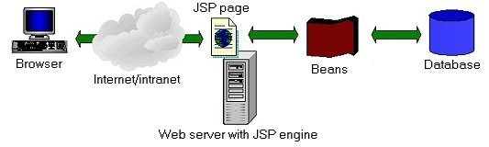

Fig.4.2.3 Basic JSP Request Model

This figure illustrates the flow of information in this model. JSP code controls interactions with JavaBeans components for business and data logic processing, and then displays the results in dynamically generated HTML mixed with static HTML code.

|  |  |
| --- | --- |
| **Scope** | **Description** |
| page | Object is accessible only by a single client from the page on which it is created. |
| request | Object is accessible by a single client for the lifetime of a single client request. |
| session | Object is accessible by a single client from anywhere in the application for the lifetime of an entire user session. |
| application | Object accessible is by any client from any page within the application for the lifetime of the application. |

**Table 4.2.2 Scope and state maintenance in JSP**

**5. Servlets:** A Servlet is quite simply a java class that adheres to the general model of a Servlet as defined by the Servlet API. A Servlet Container, also known as a Servlet Engine translates requests from whatever protocol is being used into objects that the Servlet understands, and also gives the Servlet an object which it can use to send a response. This container is also responsible for managing the lifecycle of a Servlet.

Now we have already met the idea of a JSP Container which manages JSP execution. In fact the JSP Container is only responsible for the rewriting of a JSP page to a Servlet and then allows the Servlet Container handle the actual execution.

**The basic lifecycle of a Servlet is:**

* The Servlet Container creates an instance of the Servlet.
* The Container calls the instance's init() method.
* If the Container has a request for the Servlet it will call the instance's service() method.
* Before the instance is destroyed the Container will call the destroy() method.
* Finally the instance is destroyed and marked for garbage collection.

**6. Struts:** Apache Struts 2 is an elegant, extensible framework for creating enterprise-ready Java web applications. The framework is designed to streamline the full development cycle, from building, to deploying, to maintaining applications over time.

Apache Struts2 was originally known as Web Work 2. After working independently for several years, the Web Work and Struts communities joined forces to create Struts2. This new version of Struts is simpler to use and closer to how Struts was always meant to be. Struts 2 is a pull-MVC framework. i.e. the data that is to be displayed to user has to be pulled from the Action.

## *http://img.viralpatel.net/2009/12/struts-2-request-cycle.png*

Fig. 4.2.4 Struts 2 Working

## Architecture of Struts 2:

* The normal lifecycle of struts begins when the request is sent from client. This results invoke the servlet container which in turn is passed through standard filter chain.
* The FilterDispatcher filter is called which consults the ActionMapper to determine whether an Action should be invoked.
* If ActionMapper finds an Action to be invoked, the FilterDispatcher delegates control toActionProxy.
* ActionProxy reads the configuration file such as struts.xml. ActionProxy creates an instance ofActionInvocation class and delegates the control.
* ActionInvocation is responsible for command pattern implementation. It invokes the Interceptors one by one (if required) and then invoke the Action.
* Once the Action returns, the ActionInvocation is responsible for looking up the proper result associated with the Action result code mapped in struts.xml.
* The Interceptors are executed again in reverse order and the response is returned to the Filter (In most cases to FilterDispatcher). And the result is then sent to the servlet container which in turns send it back to client.

**7. HTML:**

HTML is a language for describing web pages.

* HTML stands for Hyper Text Markup Language
* HTML is a markup language
* A markup language is a set of markup tags
* The tags describe document content
* HTML documents contain HTML tags and plain text
* HTML documents are also called web pages

**HTML Tags:**

HTML markup tags are usually called HTML tags

* HTML tags are keywords (tag names) surrounded by angle brackets like <html>
* HTML tags normally come in pairs like <b> and </b>
* The first tag in a pair is the start tag, the second tag is the end tag
* The end tag is written like the start tag, with a forward slash before the tag name
* Start and end tags are also called opening tags and closing tags.

**8. CSS:** A CSS (cascading style sheet) file allows you to separate your web sites (X)HTML content from it’s style. As always you use your (X)HTML file to arrange the content, but all of the presentation (fonts, colors, background, borders, text formatting, link effects & so on…) are accomplished within a CSS.

* CSS stands for Cascading Style Sheets
* Styles define how to display HTML elements
* Styles were added to HTML 4.0 to solve a problem
* External Style Sheets can save a lot of work
* External Style Sheets are stored in CSS files

**9. Jquery:**

* jQuery is a lightweight, "write less, do more", JavaScript library.
* The purpose of jQuery is to make it much easier to use JavaScript on your website.
* jQuery takes a lot of common tasks that require many lines of JavaScript code to accomplish, and wraps them into methods that you can call with a single line of code.
* jQuery also simplifies a lot of the complicated things from JavaScript, like AJAX calls and DOM manipulation.

The jQuery library contains the following features:

* HTML/DOM manipulation
* CSS manipulation
* HTML event methods
* Effects and animations
* AJAX
* Utilities

4.3 Introduction to Mysql:

**Introduction:** The MySQL (R) software delivers a very fast, multi-threaded, multi-user, and robust SQL (Structured Query Language) database server. MySQL Server is intended for mission-critical, heavy-load production systems as well as for embedding into mass-deployed software. MySQL is a trademark of MySQL AB.

**History of MySQL:** We started out with the intention of using mSQL to connect to our tables using our own fast low-level routines. However, after some testing, we came to the conclusion that mSQL was not fast enough or flexible enough for our needs. This resulted in a new SQL interface to our database but with almost the same API interface as mSQL. This API was designed to allow third-party code that was written for use with mSQL to be ported easily fr use with MySQL. The derivation of the name MySQL is not clear. Our base directory and a large number of our libraries and tools have had the prefix ``my'' for well over 10 years. However, co-founder Monty Widenius's daughter is also named My. The name of the MySQL Dolphin (our logo) is Sakila. Sakila was chosen by the founders of MySQL AB from a huge list of names suggested by users in our ``Name the Dolphin'' contest. The winning name was submitted by Ambrose Twebaze, an open source software developer from Swaziland, Africa. According to Ambrose, the name Sakila has its roots in SiSwati, the local language of Swaziland. Sakila is also the name of a town in Arusha, Tanzania, near Ambrose's country of origin, Uganda.

[**Main Features of MySQL**](E:mysqlDocsmanual_toc.html#Features)**:**

The following list describes some of the important characteristics of the MySQL Database Software.

1. **Internals and Portability**

* Written in C and C++.
* Tested with a broad range of different compilers.
* Works on many different platforms. Uses GNU Automake, Autoconf, and Libtool for portability.
* APIs for C, C++, Eiffel, Java, Perl, PHP, Python, Ruby, and Tcl are available.
* Fully multi-threaded using kernel threads. This means it can easily use multiple CPUs if they are available.
* Provides transactional and non-transactional storage engines.
* A very fast thread-based memory allocation system.
* Very fast joins using an optimized one-sweep multi-join.
* In-memory hash tables which are used as temporary tables.
* SQL functions are implemented using a highly optimized class library and should be as fast as possible. Usually there is no memory allocation at all after query initialization.
* The MySQL code is tested with Purify (a commercial memory leakage detector) as well as with Valgrind, a GPL tool.
* The server is available as a separate program for use in a client/server networked environment. It is also available as a library that can be embedded (linked) into standalone applications. Such applications can be used in isolation or in environments where no network is available.

**2. Column Types**

* Many column types: signed/unsigned integers 1, 2, 3, 4, and 8 bytes long, FLOAT, DOUBLE, CHAR, VARCHAR, TEXT, BLOB, DATE, TIME, DATETIME, TIMESTAMP, YEAR, SET, ENUM, and OpenGIS geometry types.
* Fixed-length and variable-length records.

**3. Commands and Functions**

* Full operator and function support in the SELECT and WHERE clauses of queries. For example:
  + mysql> SELECT CONCAT(first_name, ' ', last_name)
    - FROM tbl_name
    - WHERE income/dependents > 10000 AND age > 30;
* Support for LEFT OUTER JOIN and RIGHT OUTER JOIN with both standard SQL and ODBC syntax.
* DELETE, INSERT, REPLACE, and UPDATE return the number of rows that were changed (affected). It is possible to return the number of rows matched instead by setting a flag when connecting to the server.

**4. Security:** A privilege and password system that is very flexible and secure, and allows host-based verification. Passwords are secure because all password traffic is encrypted when you connect to a server.

**5. Scalability and Limits**

* Handles large databases. We use MySQL Server with databases that contain 50 million records. We also know of users that use MySQL Server with 60,000 tables and about 5,000,000,000 rows.
* Up to 32 indexes per table are allowed. Each index may consist of 1 to 16 columns or parts of columns. The maximum index width is 500 bytes (this may be changed when compiling MySQL Server). An index may use a prefix of a CHAR or VARCHAR column.

**6. Connectivity**

* Clients may connect to the MySQL server using TCP/IP sockets on any platform. On Windows systems in the NT family (NT, 2000, or XP), clients may connect using named pipes. On Unix systems, clients may connect using Unix domain socket files.
* The Connector/JDBC interface provides MySQL support for Java client programs that use JDBC connections. Clients may be run on Windows or Unix. Connector/JDBC source is available.

**7. Clients and Tools**

* The MySQL server has built-in support for SQL statements to check, optimize, and repair tables. These statements are available from the command line through the mysqlcheck client. MySQL also includes myisamchk.

[**How Big MySQL Tables Can Be**](E:mysqlDocsmanual_toc.html#Table_size)

### MySQL Version 3.22 had a 4 GB (4 gigabyte) limit on table size. With the MyISAM storage engine in MySQL Version 3.23, the maximum table size was increased to 8 million terabytes (2 ^ 63 bytes). With this larger allowed table size, the maximum effective table size for MySQL databases now normally is determined by operating system constraints on file sizes, not by MySQL internal limits.

|  |  |
| --- | --- |
| **Operating System** | **File-Size Limit** |
| Linux-Intel 32-bit | 2 GB |
| Linux-Alpha | 8 TB |
| Solaris 2.5.1 | 2 GB |
| Solaris 2.6 | 4 GB |
| Solaris 2.7 Intel | 4 GB |
| Solaris 2.7 UltraSPARC | 512 GB |

# Table 4.3.1: Operating system Vs file-size limits

**5.**

**Use Case Diagramme**

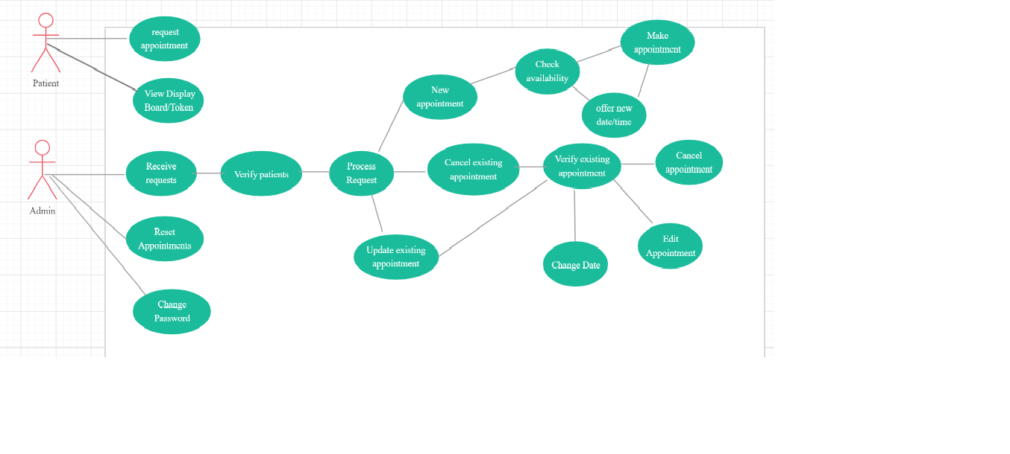

**Class Diagramme**

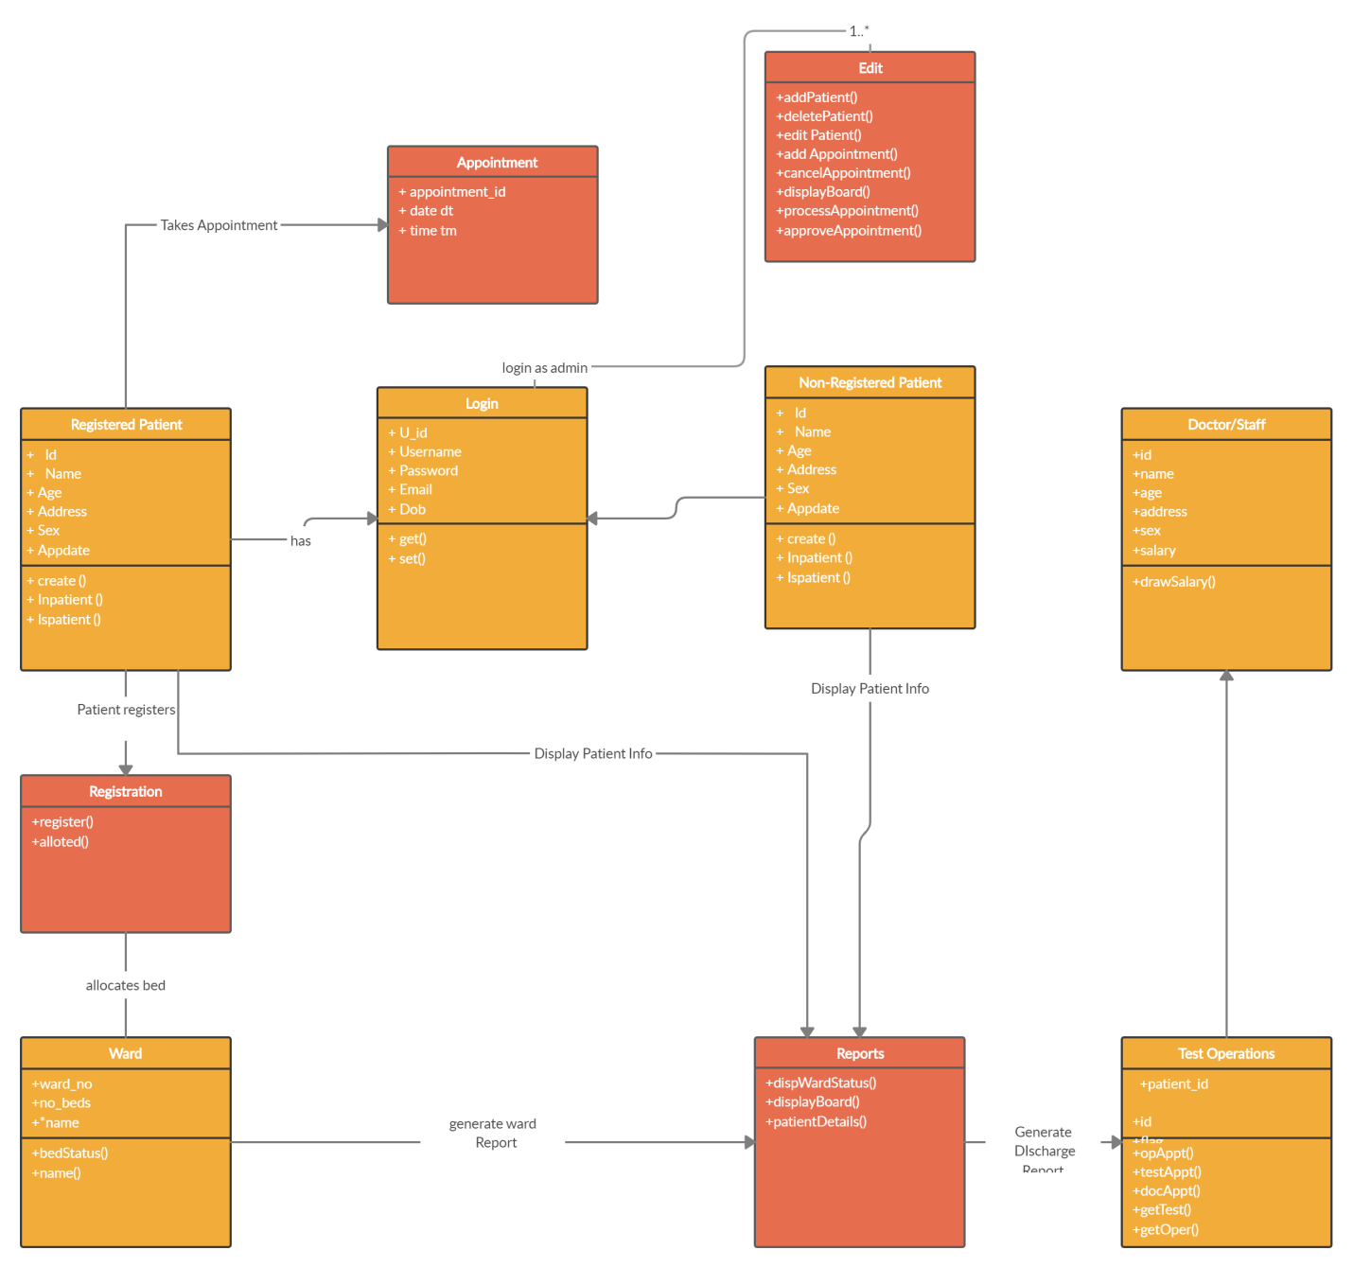

**Sequence Diagramme**

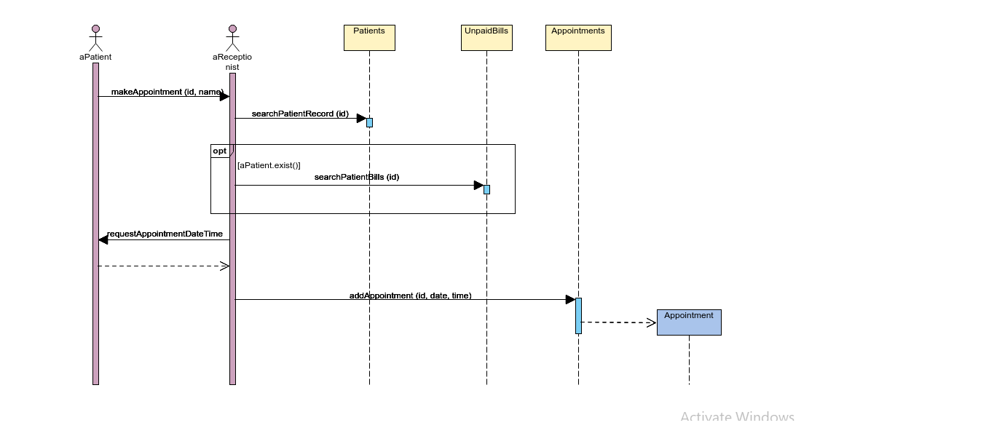

**E-R Diagramme**

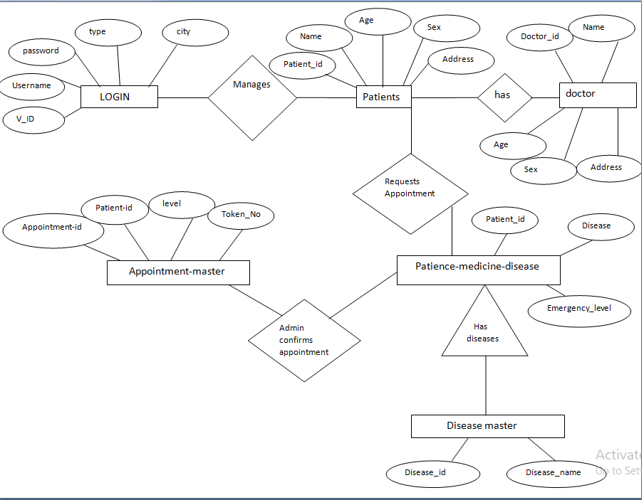

**DATA FLOW DIAGRAM(DFD)** :-

Data Flow diagram is the logical representation of the data flow of the project. The DFD is drawn using various symbols. It has a source and a destination.

**Circle -**  It represents the Process.

**Squares**- It represents the source and destination.

**Arrows-** It represents the data flow.

One reader can easily get the idea about the project through Data Flow Diagram.

**0 Level DFD**

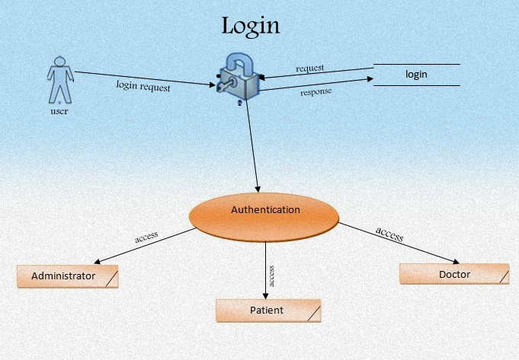

View Website

View Display Board

Approve/Cancel Appointments

Receive Request for Appointments

View Display Board

Request Appointments

Doctors

Users

Appointment Booking System

Admin

Patient

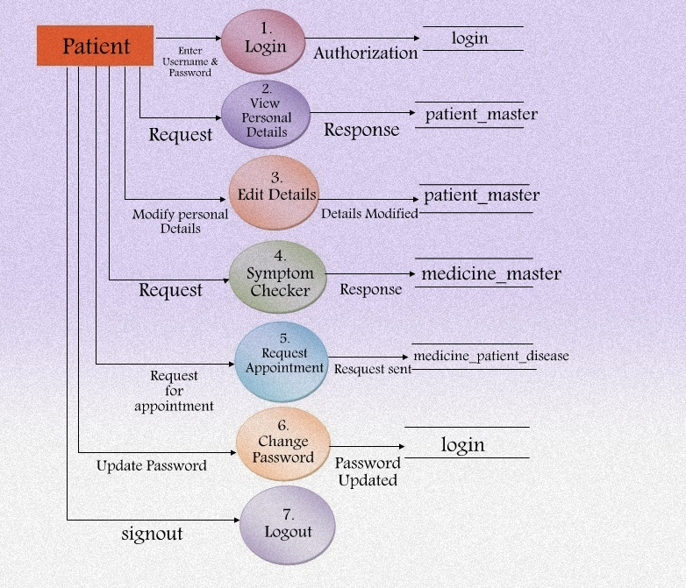

**Admin**

Login Table

Patient Table

Disease_master

Not

Not validated

Username

Admin

Password

+

Appointment_master

Appointment_master

Patient_Medicine_Disease

**Patient**

Login Table

Login Table

Patient Table

Username Not

Patient

, Password validated

Appointment_master

Patient_medicine_disease

**Data Base Design**

Login Table

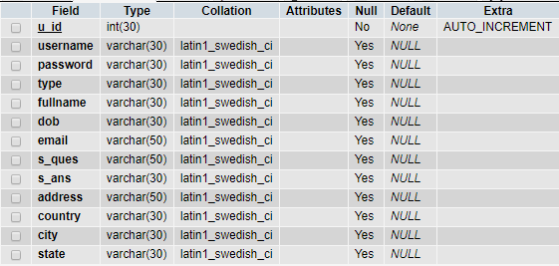

Patient Master Table

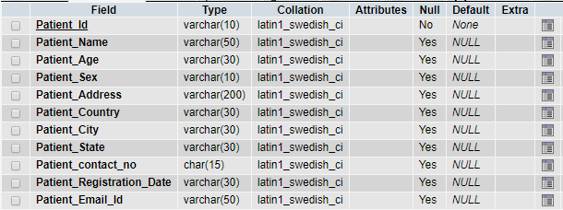

Patient_Medicine_Master

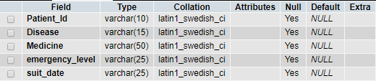

Doctor_Master

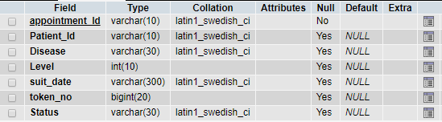

Disease_Master

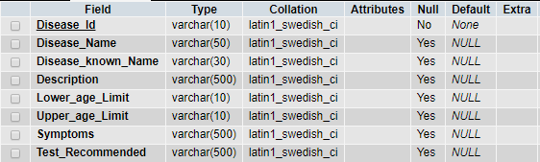

Appointment_Master

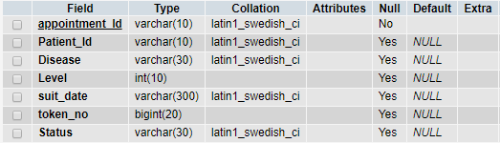

* 1. **Screen-Shots**

Home Screen

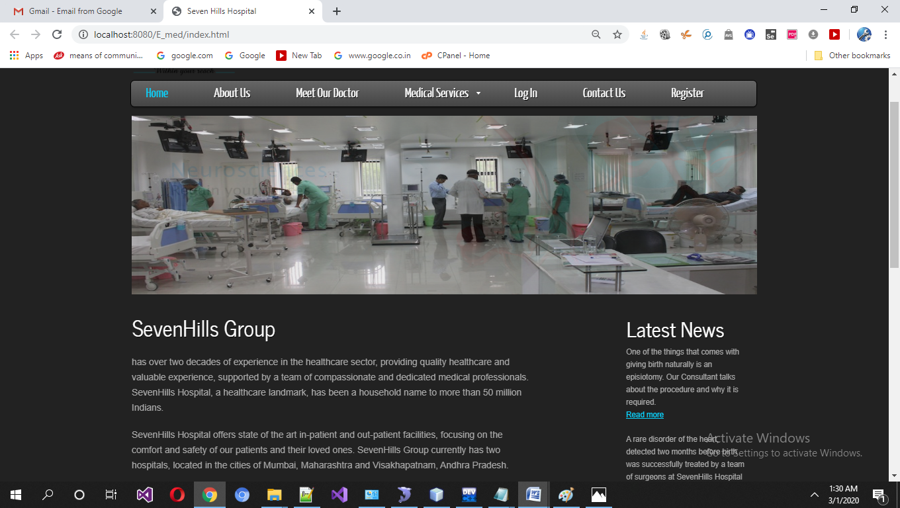

Registration Screen

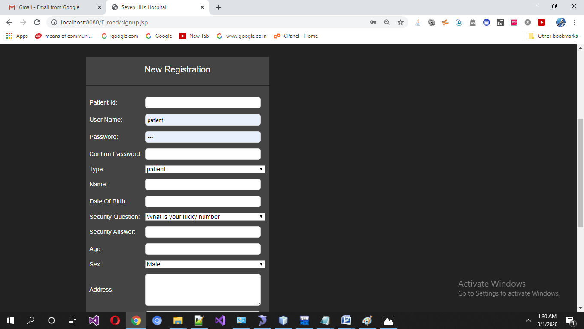

Login Screen

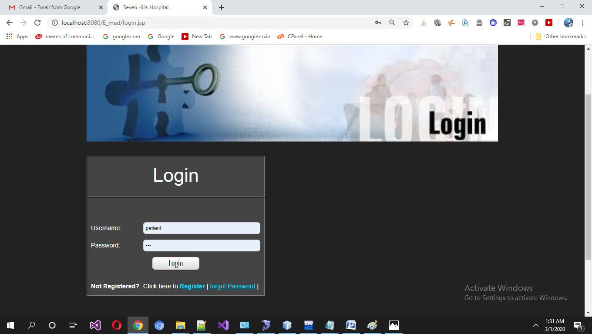

Patient Home Screen

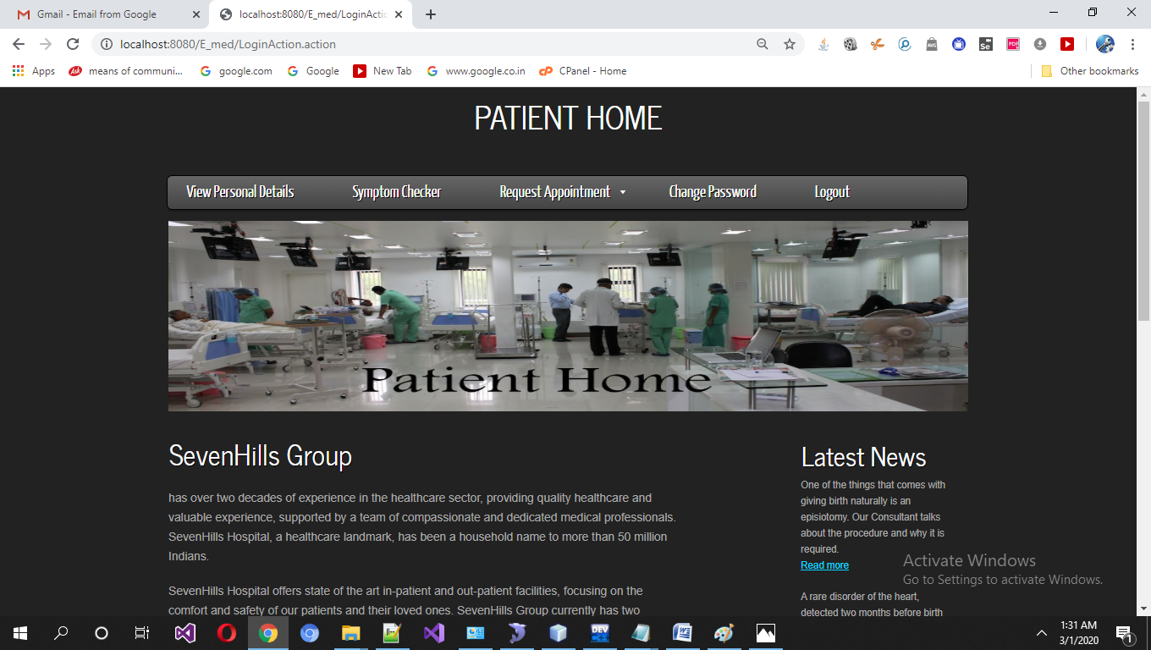

Patient View Personal Details

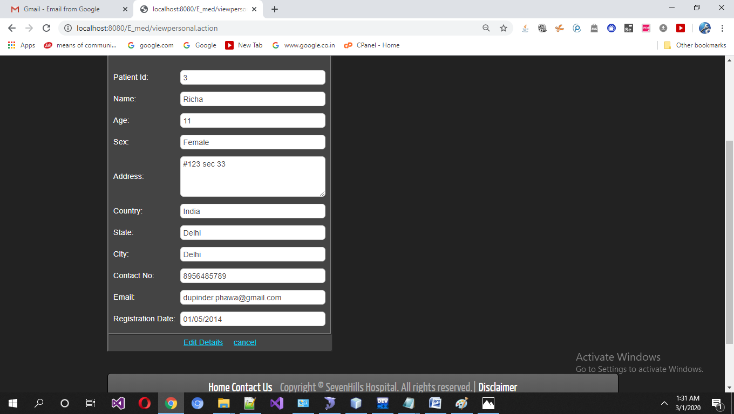

Patient Request Appointment

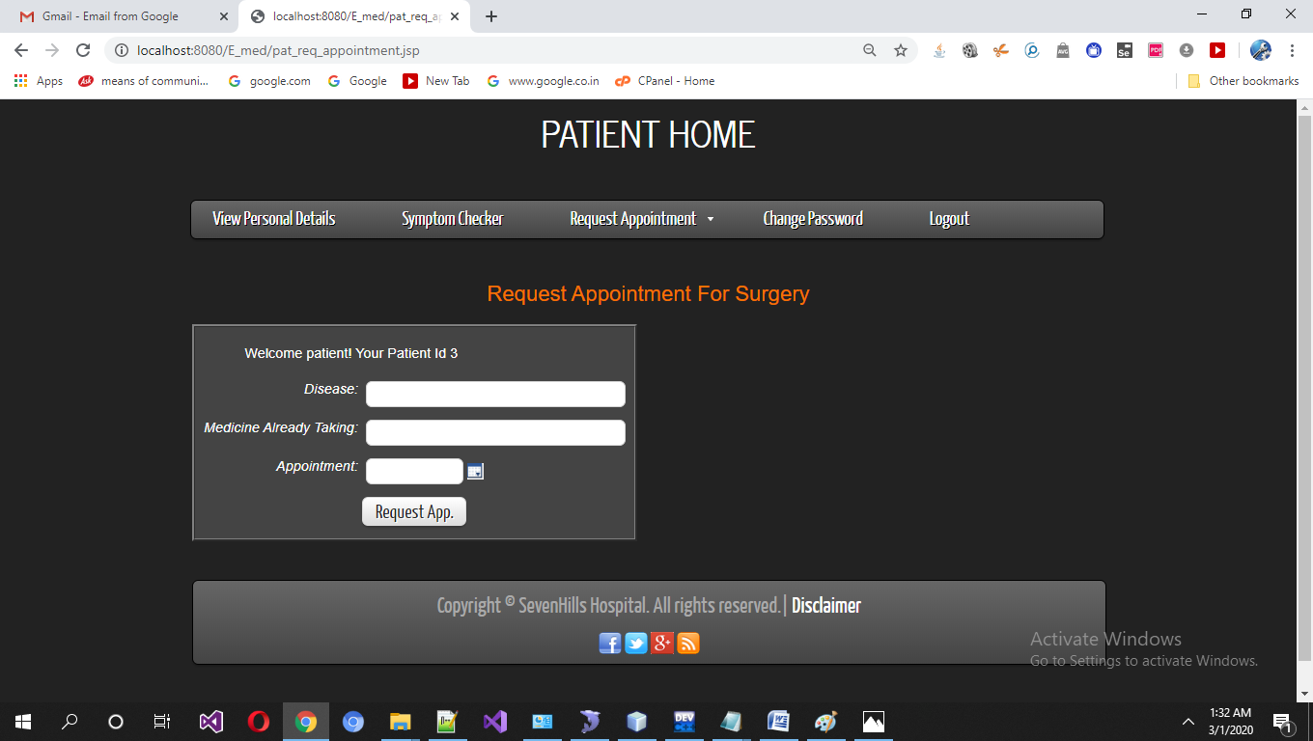

Patients View Appointment and Tokens

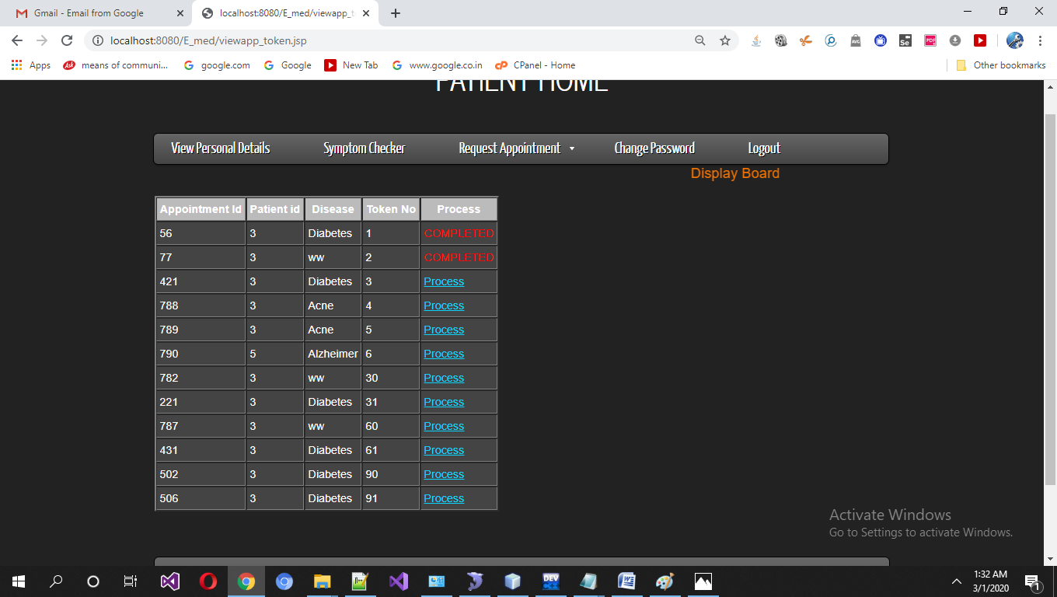

Patient Change Password

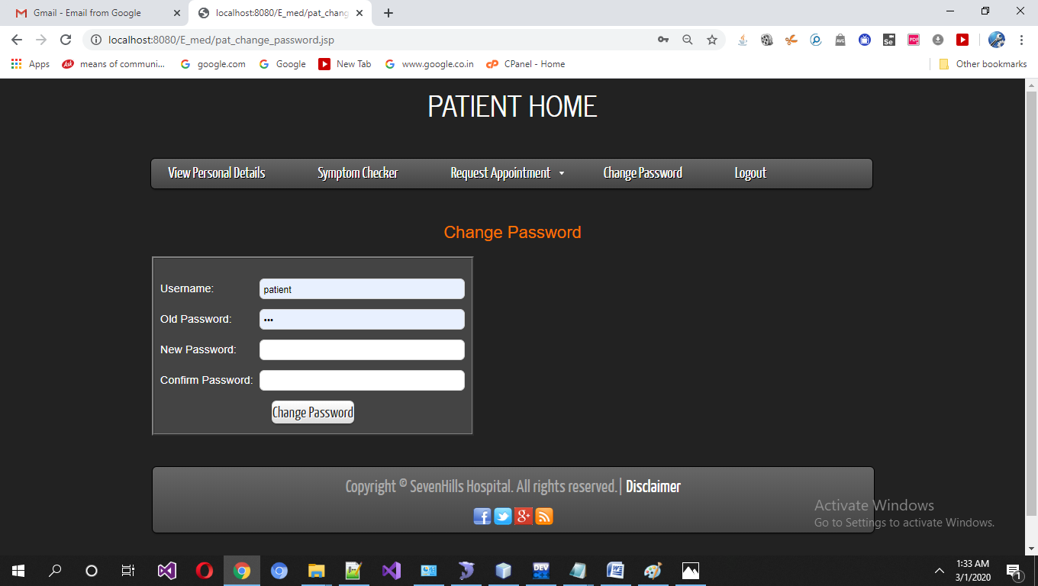

Admin Home Screen

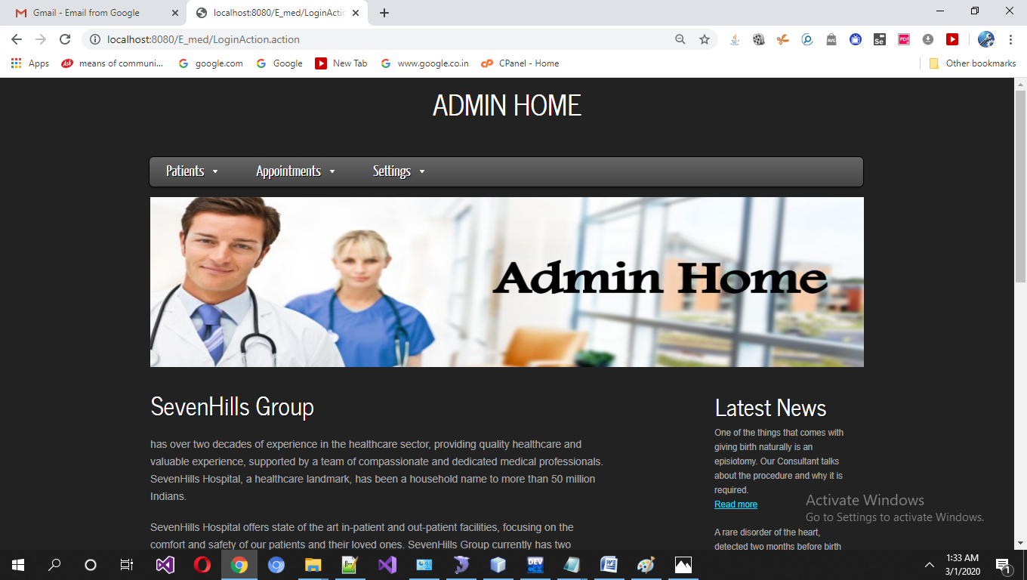

Admin Add Patients Details

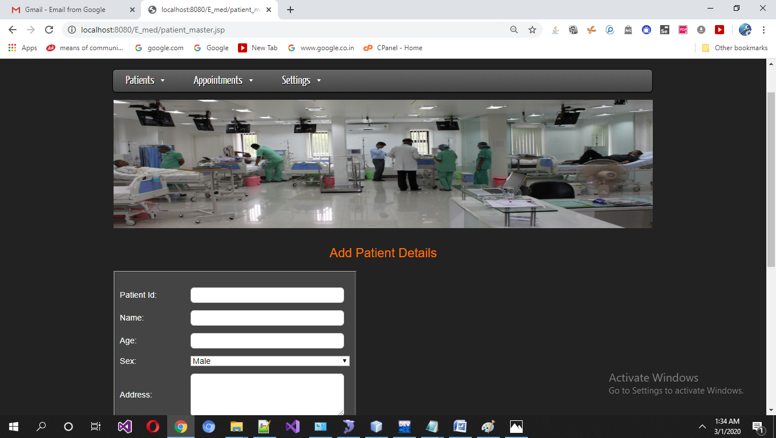

Admin Delete Patient Details

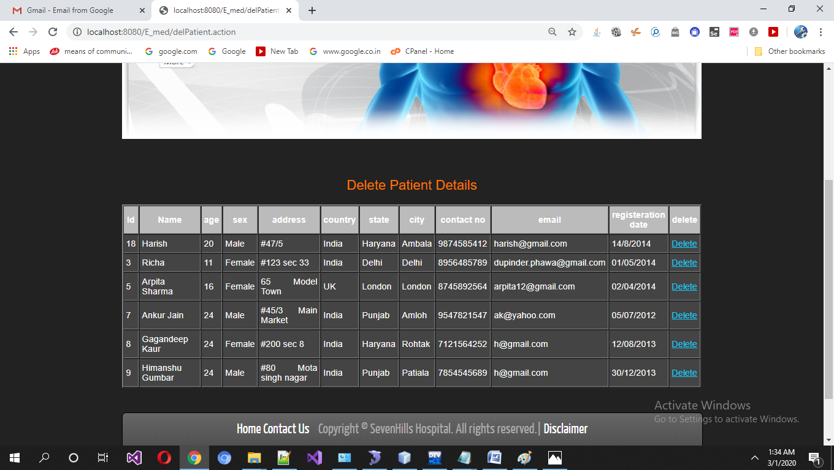

Admin Edit Patient Details

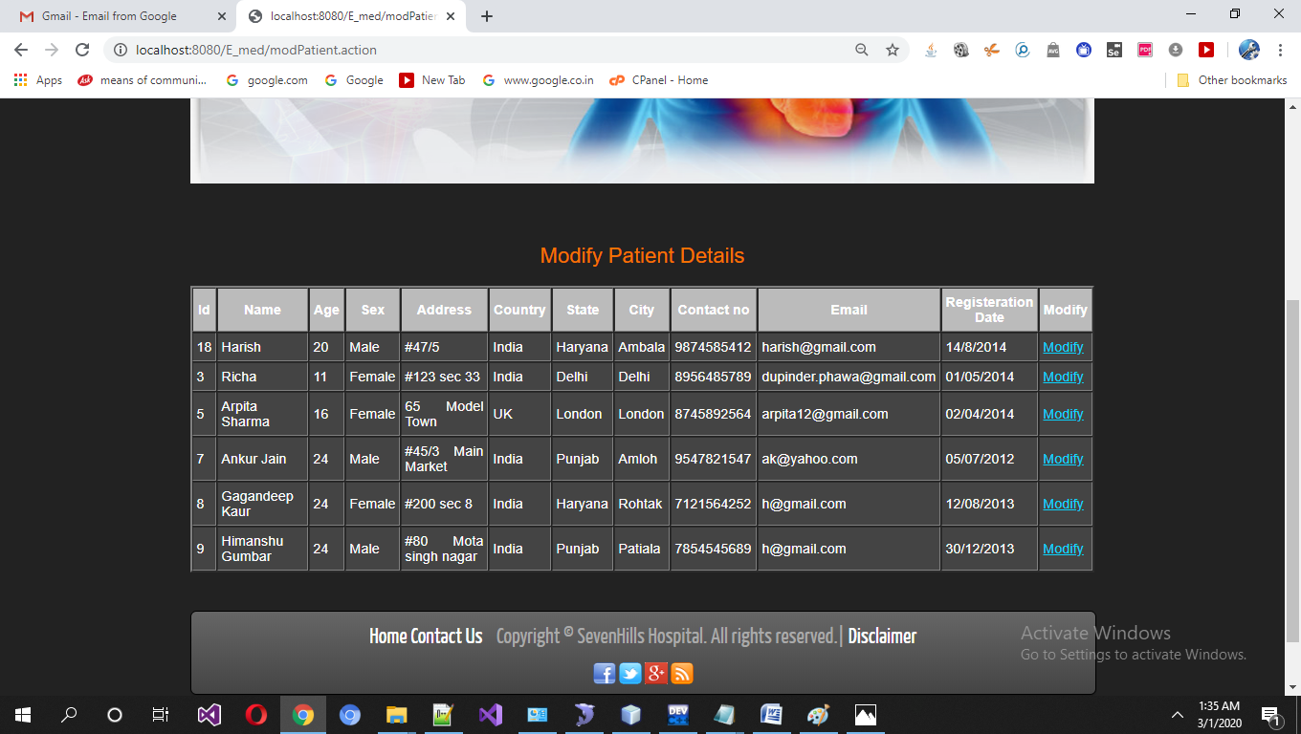

Appointment Requests

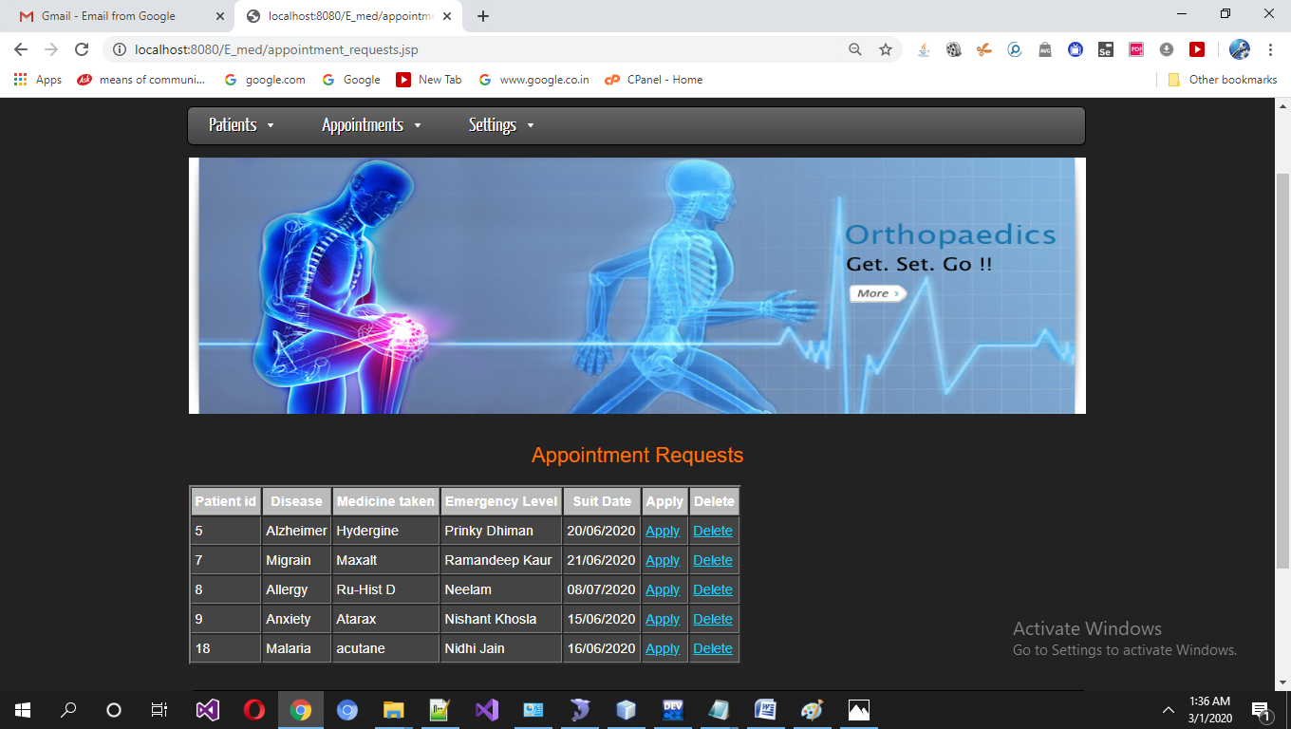

Admin approve appointments

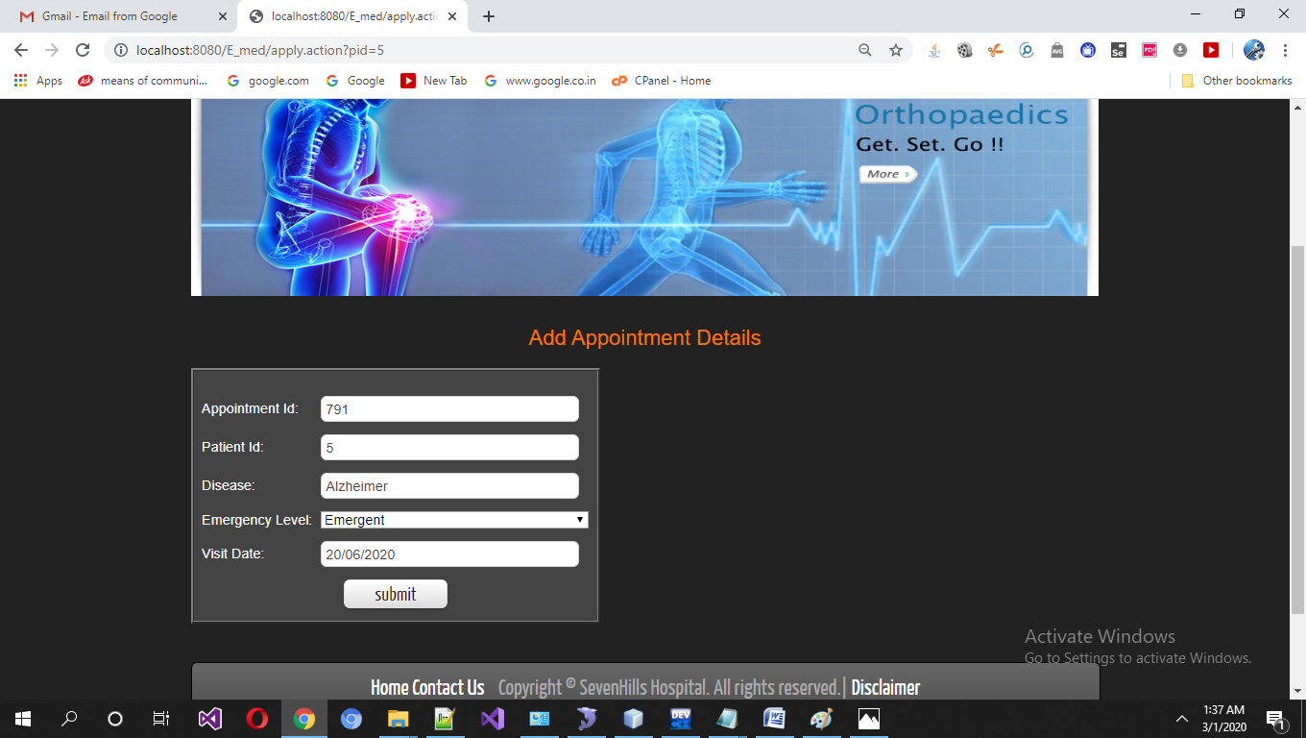

DisplayBoard

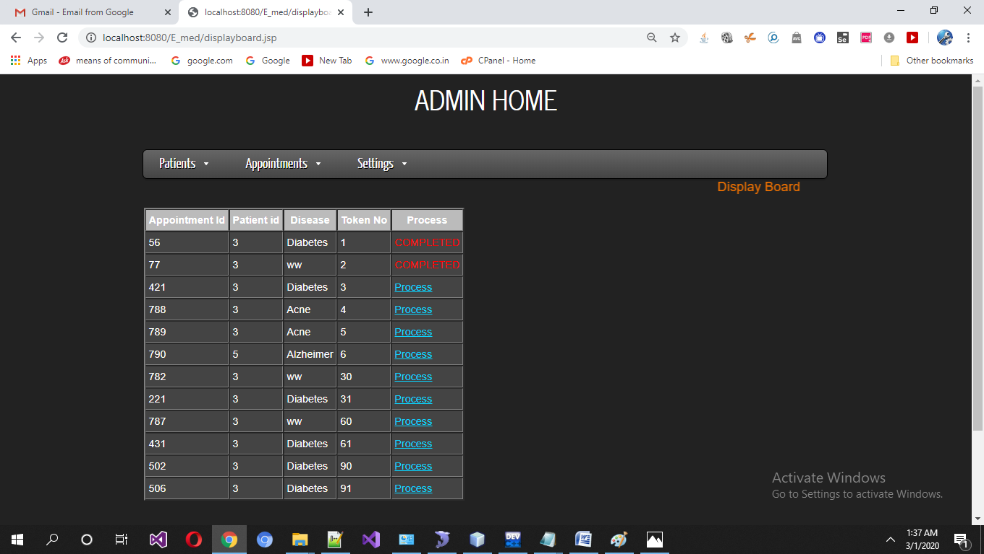

Admin add appointments

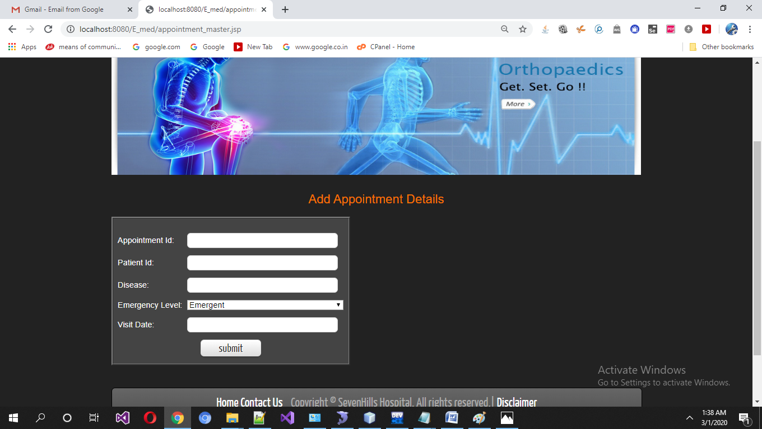

Admin Change Password

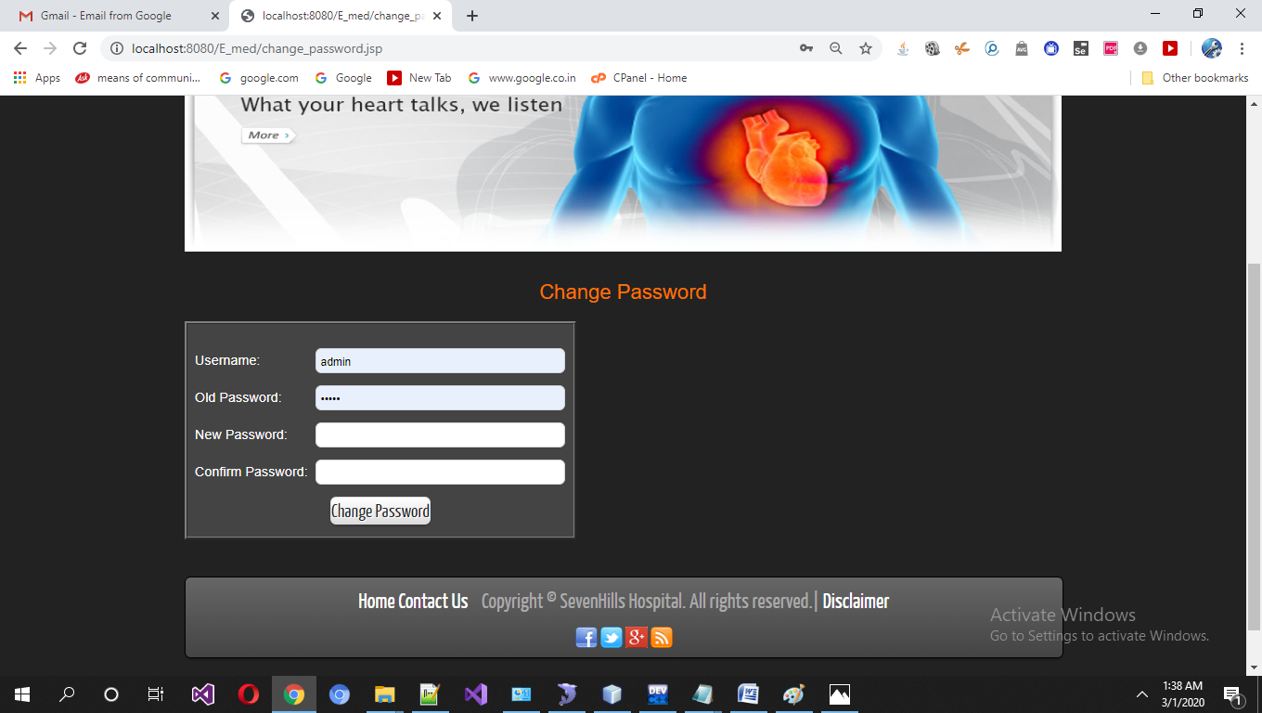

**7. RESULT & DISCUSSION**

The system can automate the process of managing data of Doctors/Patient. It will manage all the information about the Patient Appointments . The doctors can view their patient using this system. The Patients can see his appointments using this system. The Patients can match their symptoms and can find out matching disease they are suffering from. Administrator can generate display board depending on emergency levels. Only the Patients/Administrator can visit the site or can access information.

Without the use of online system the company has to record the data in the registers which entries were to be updated daily with updation of data.. Thus it was very time consuming process.

This system has successfully achived its design goal. It results as follows:

* All the information about the doctors has been managed.
* Patients can easily check the disease they have by matching the symptoms.
* Appointments has been successfully requested and responsed by the doctors.
* Administrator has the privilege that he can create, modify the database.
* Information modified when need arises of the new patients and doctors.
* To intimate user according to the threshold value set for Quantity.
* Users can easily view their personal details and can modify their particulars.
* Patients can check his/her appointments and token no for their turn.

**8. FUTURE & SCOPE**

Information technology has been like a boom in almost every kind of management system. The continuous improvement in the field of technology along with increasing complications in day-to-day life has resulted in the online information system.

Computers have reduced all the paper work of any organization but online information provides more flexibility to its customers. Online information provides much more facilities to its users.

An expert method is a **patient appointment system** that control flow of patient appointments and generate display board for each day so a sequence of appointments can be handled and expert system deal with emergency levels which may be Emergent, Urgent, Not-Urgent and the highest emergency level patient are attended first and display board is automatically refreshed to re-arrange the appointments. These examples from your through the problem domain can either have the correct class labels related to them, categorized as supervised learning, or sub–classes of examples can automatically be found from the inside the data.

* **User Friendly**: The system produced is user friendly, understandable and easy to use so that the users of the system can easily learn to use the system. For this the system is made menu-driven with well-documented programs.
* **Time Element (response and processing time)**: The response time of the system is very less and takes less time to execute queries and triggers.
* **Maximum Throughput**: The system gives maximum throughput with relevant output
* **Robustness**: The system will be able to handle undesirable situations and errors encountered at various levels e.g. if the user supplies invalid input for processing, the system gracefully halts, displaying a message to the user indicating the cause of the error and prompting him it enter the correct input.
* **Flexibility:** The system is flexible in nature so that likely changes and alterations can easily be made.
* **Information Security:** Records in the system must be safe, confidential and must be prevented from unauthorized access.
* **Moral and User Satisfaction**: System will be able to satisfy the user requirements; this is the main and conspicuous measure of the system performance. Also the system must raise the moral of the user. The higher the moral, greater the expected work performance level.

**SCOPE OF Appointment System:**

Computer Aided Patient Appointment System can be widely used to many clinics. As all the information regarding patients appointments and their corresponding medicines are gathered at one single place through this system. It works on the web so it can be used anywhere in the world very easily and can take benefits of it. Patients can also find the token no which avoiding waiting in turn. Thus Appointment System has a wide scope in future given as:

* As it is a web application, can be easily used on web and can be accessed by doctors and patients on worldwide.
* Patients can consult and check symptoms they experience and can match them through this website. They will get to know about the disease they are suffering from. Also they will get the prescribed medicine related to that disease.
* Online appointments make this web application a cutting edge from other manual systems where patients have to stand in a long queue just to get an appointment. But with the help of this system they can take appointments very easily.
* Doctors need not to remember his schedule, his appointments; he can manage/view all this information just by signing up on this web application.
* In future it can also be used as an effective expert medical system which provides diagnosis information.

**BIBLIOGRAPHY**

1) [www.google.com](http://www.google.com)

2) [www.wikipedia.org](http://www.wikipedia.org)

3) Jewei Han and Micheline Kamber(2005) “Elementary implementation of Tomcat”.

4) The complete reference for Java by Helbert Schildt

5) The complete reference for Java Server Pages by Head First

6) John M. Pierre(2000) “Practical issues for automated generation of blogs”

7) Google News [www.googlenews.com](http://www.googlenews.com)

8) Microsoft Network [www.msn.com](http://www.msn.com)

9) CDNOW [www.cdnow.com](http://www.cdnow.com)

10) Lycos [www.lycos.com](http://www.lycos.com)

11) Eblog.com

12) Bloggers.com